Mali

## Political Stability Estimate Data

The data set shows the political stability estimate of the country each year.

## # A tibble: 19 x 5  
## country iso3c date stability stabilityCategory4   
## <chr> <chr> <dbl> <dbl> <chr>   
## 1 Mali MLI 1996 0.364 moderately stable   
## 2 Mali MLI 1998 0.427 moderately stable   
## 3 Mali MLI 2000 0.240 moderately stable   
## 4 Mali MLI 2002 0.411 moderately stable   
## 5 Mali MLI 2003 0.258 moderately stable   
## 6 Mali MLI 2004 0.453 moderately stable   
## 7 Mali MLI 2005 0.176 moderately stable   
## 8 Mali MLI 2006 0.414 moderately stable   
## 9 Mali MLI 2007 0.231 moderately stable   
## 10 Mali MLI 2008 0.210 moderately stable   
## 11 Mali MLI 2009 -0.0756 moderately unstable  
## 12 Mali MLI 2010 -0.183 moderately unstable  
## 13 Mali MLI 2011 -0.708 moderately unstable  
## 14 Mali MLI 2012 -2.03 highly unstable   
## 15 Mali MLI 2013 -1.72 highly unstable   
## 16 Mali MLI 2014 -1.71 highly unstable   
## 17 Mali MLI 2015 -1.69 highly unstable   
## 18 Mali MLI 2016 -1.62 highly unstable   
## 19 Mali MLI 2017 -1.91 highly unstable

## Political Stability Estimate Plot

The plot shows the trends of stabilization and destabilization for the each country.

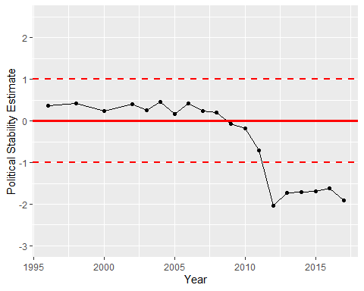

Political Stability Trend